2020-05-27

Homework 6

CESG506

Kristinn Hlíðar Grétarsson

# Problem 3

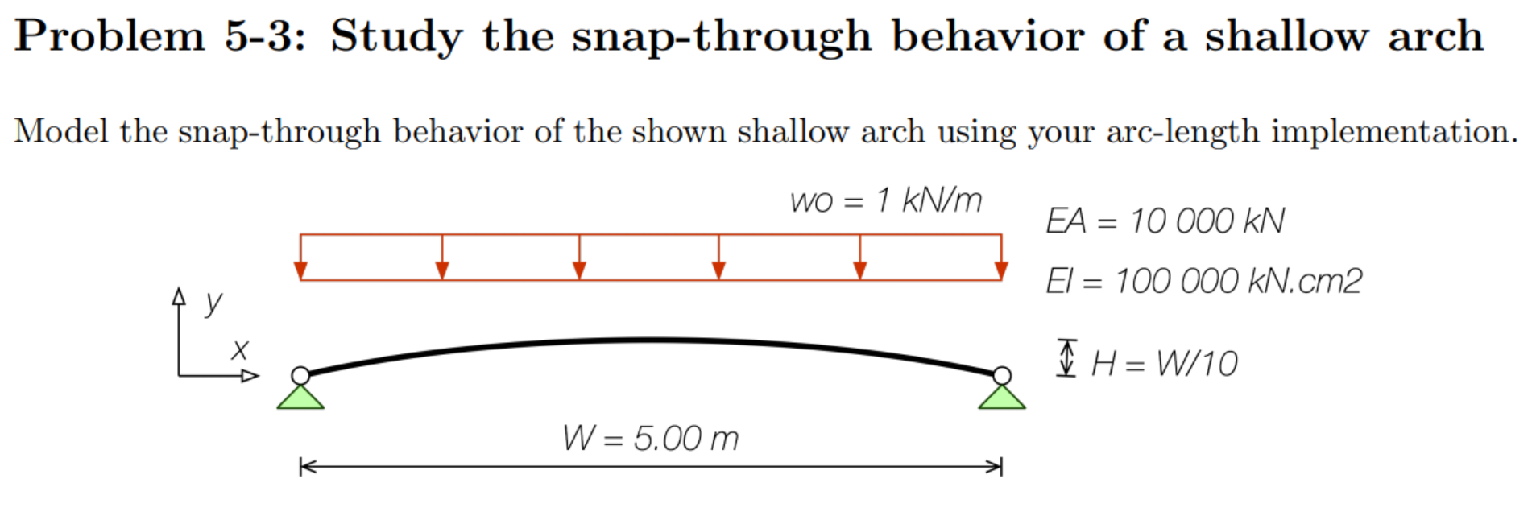

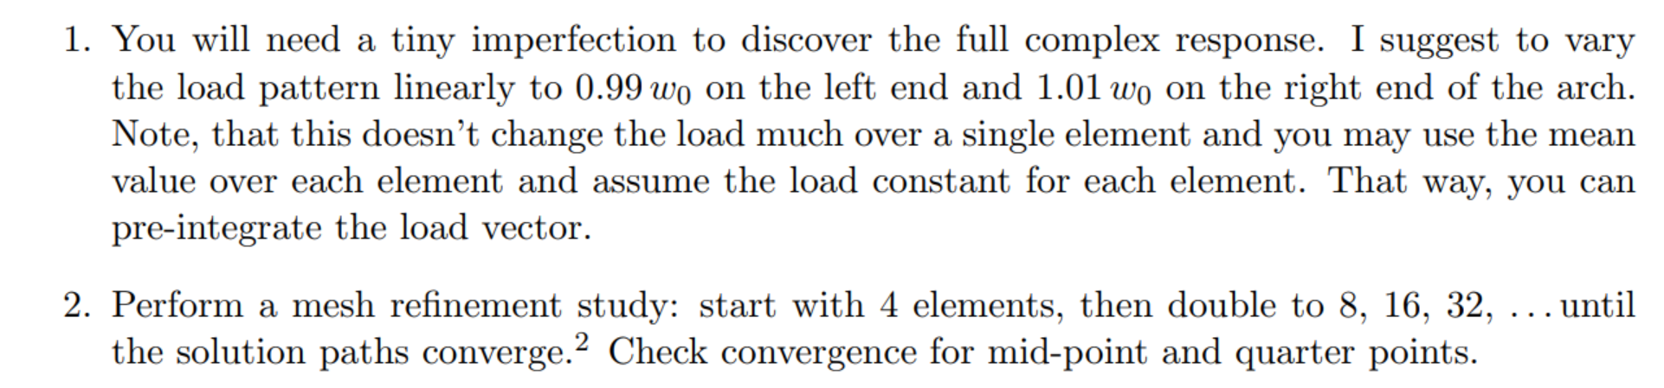

## Solution

Code was run with increasingly finer mesh and vertical displacement of ¼ point, ½ point and ¾ point were plotted. The results can be seen in the images below.

For meshes with 4 and 8 elements the strong formulation behaves in a wildly different manner compared to the weak form formulation. Once the mesh refinement hits 16 elements and higher, the strong form can be seen converging towards the weak form solution. While the weak form has converged to a solution much faster than the strong form.

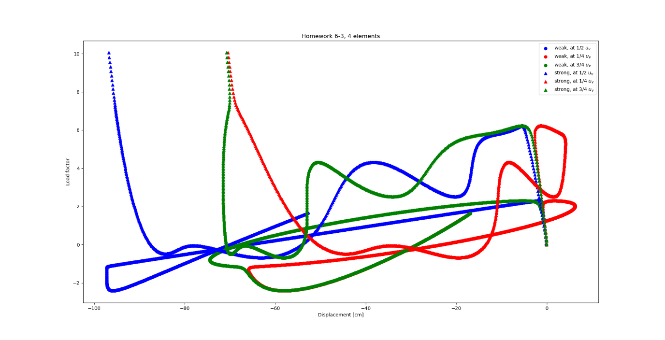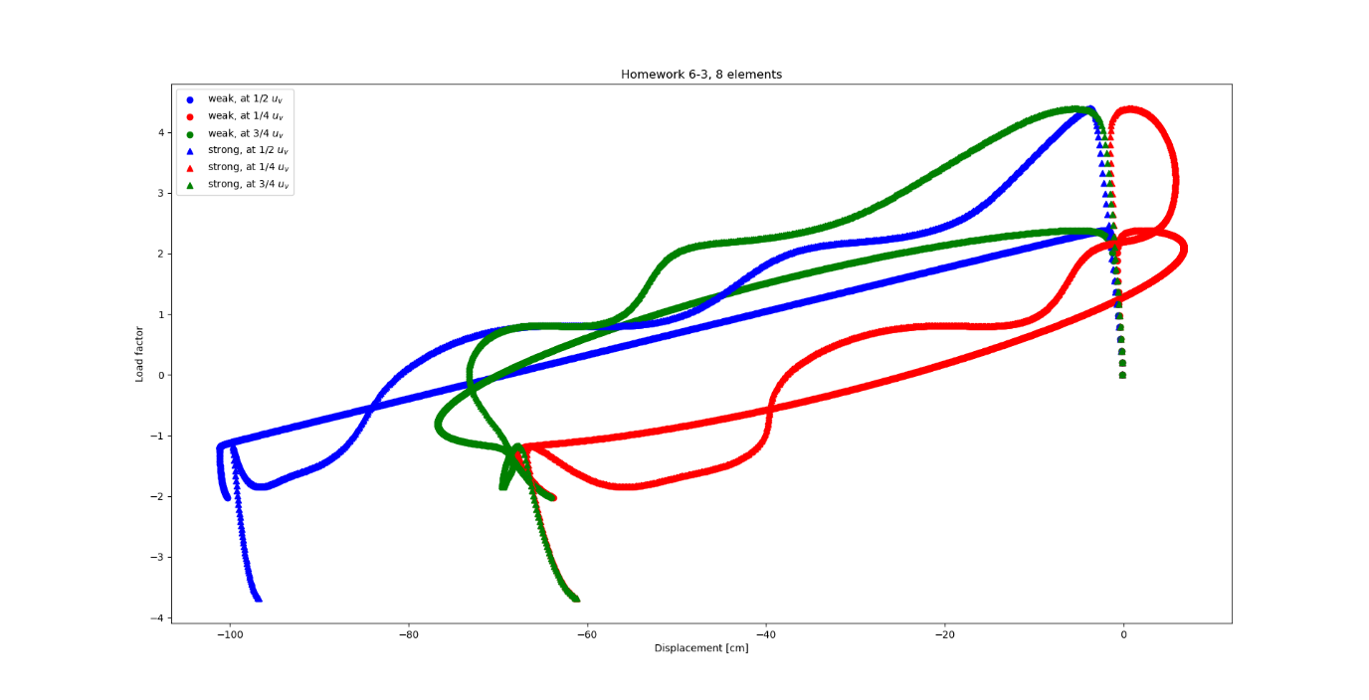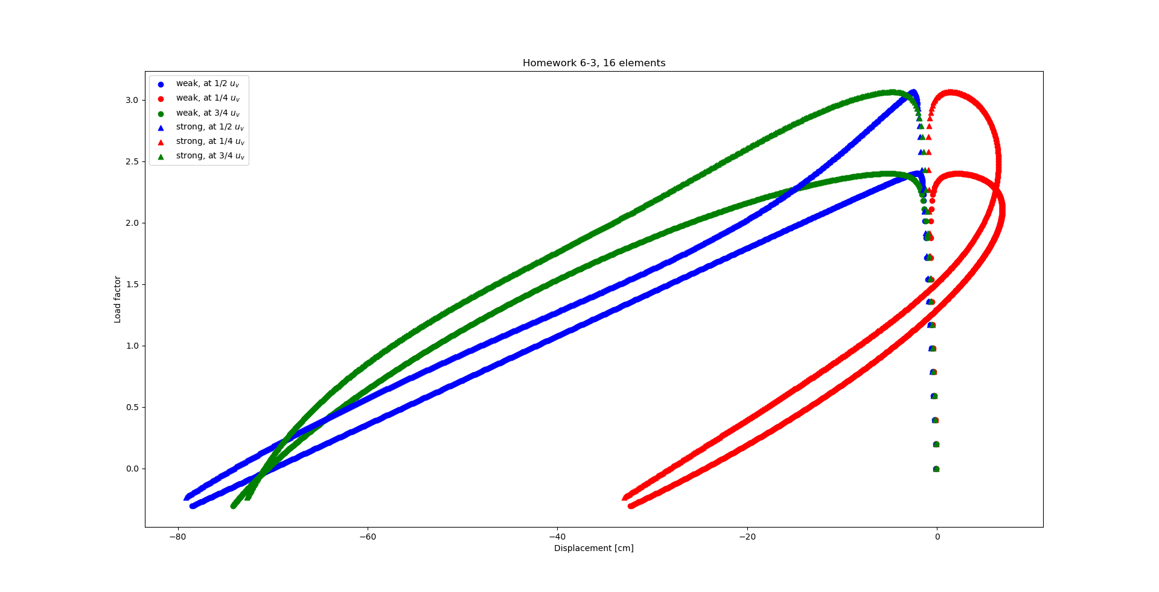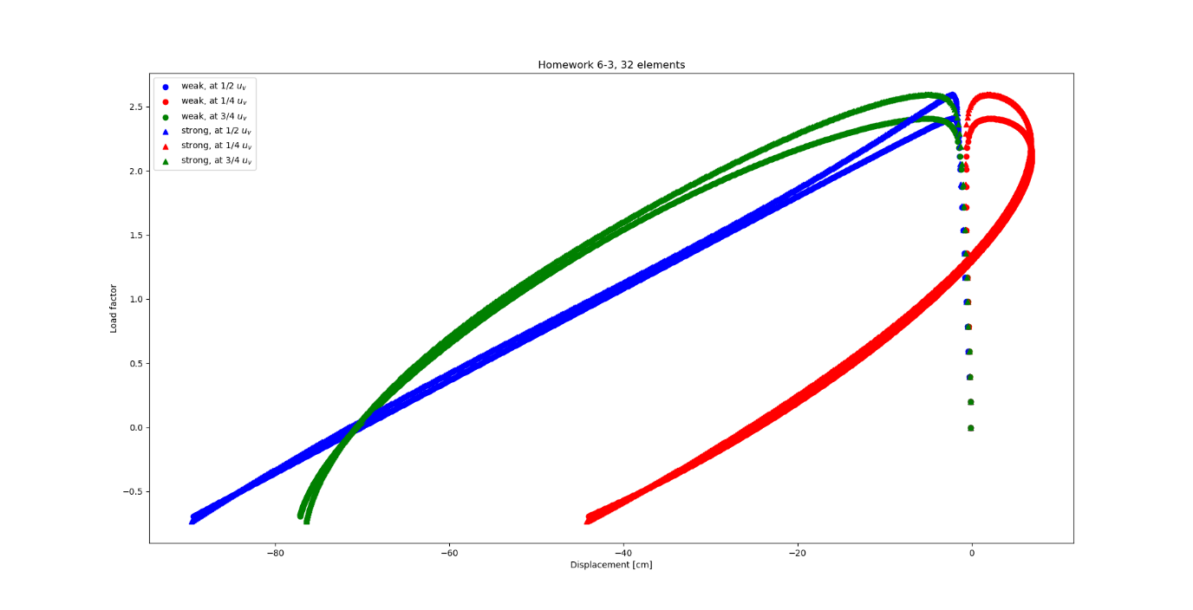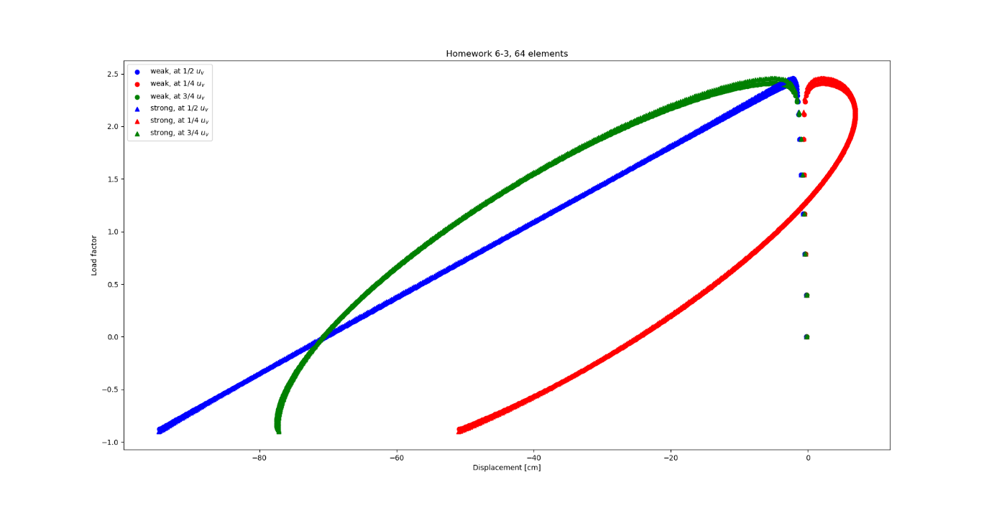

# Problem 4

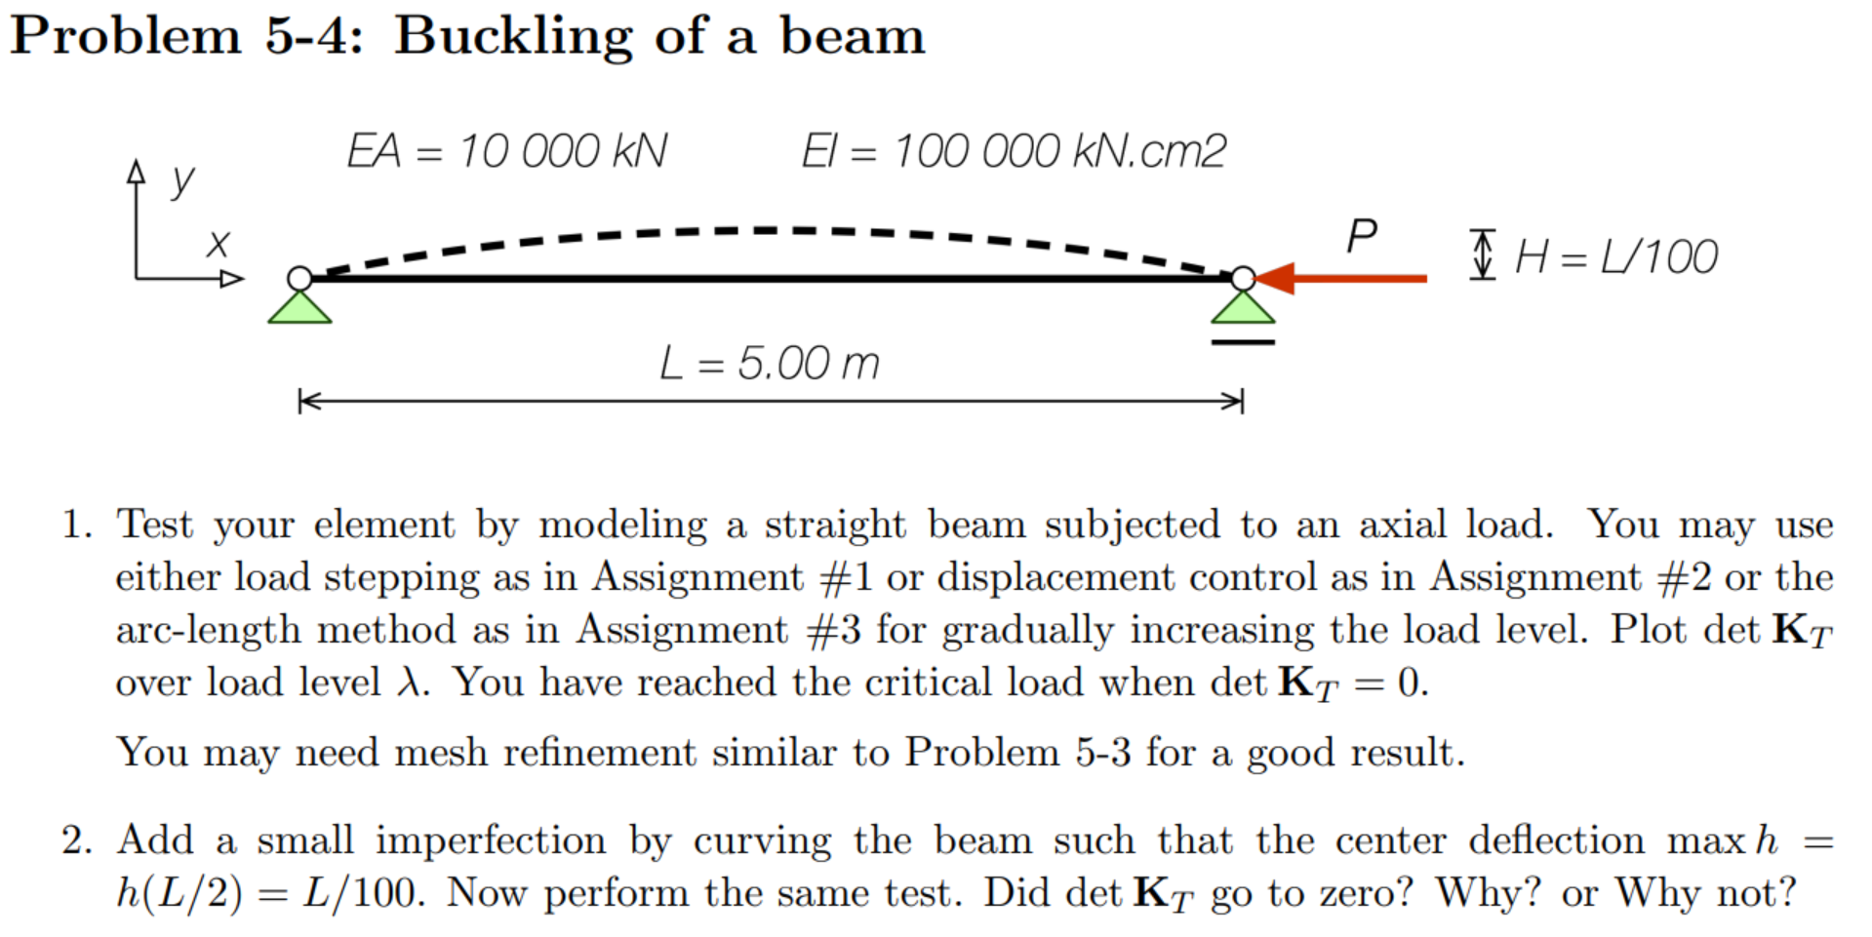

## Solution – Straight beam

Plotting determinant of the stiffness matrix over load factor shows that the stiffness matrix becomes singular at the theoretical buckling capacity.

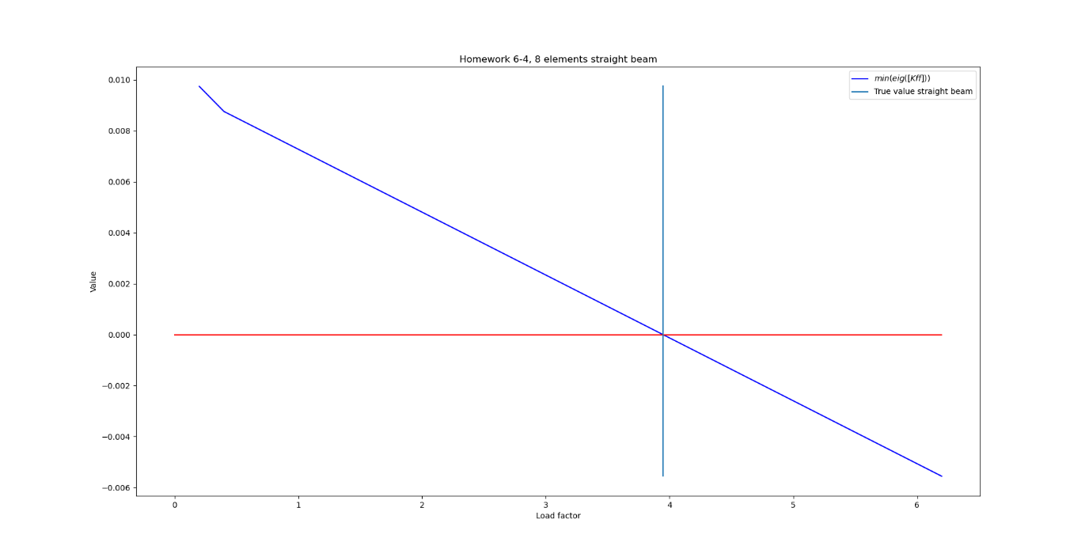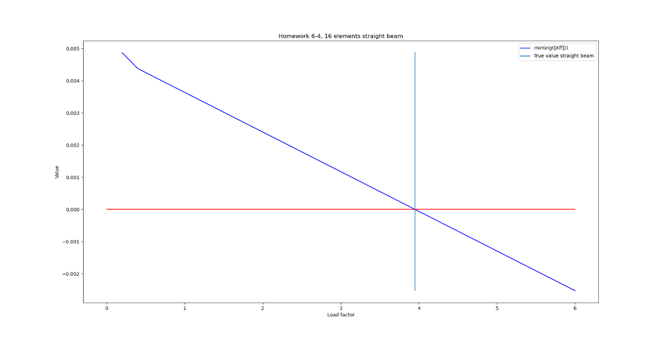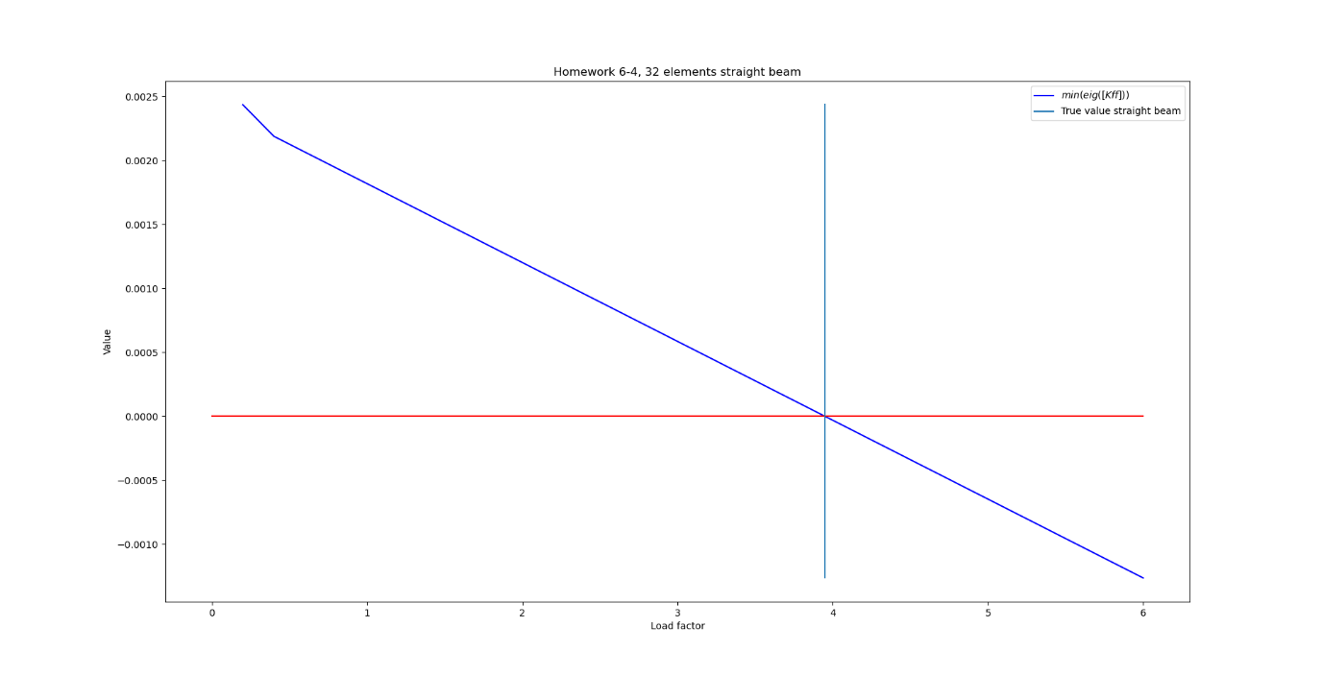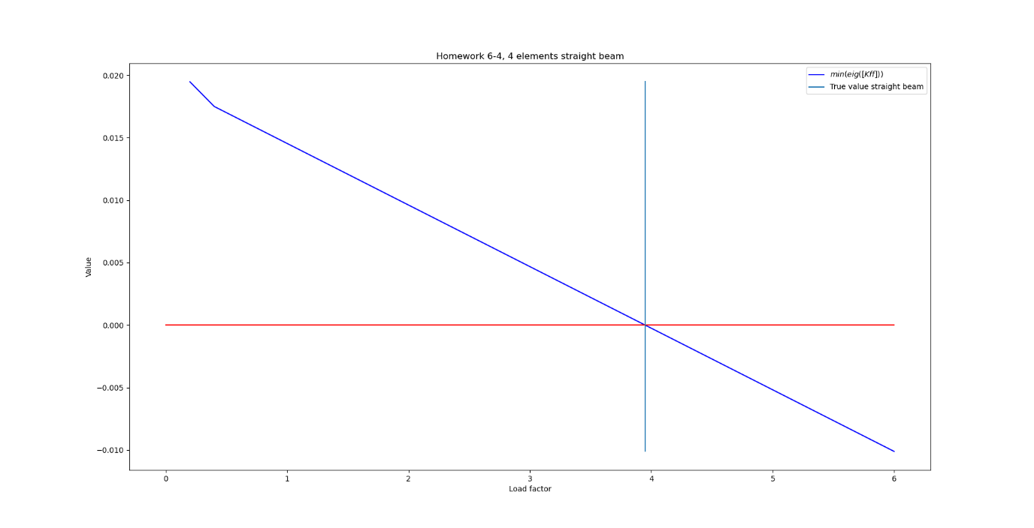

## Solution – Curved beam

Adding a small curve to the beam changed the behaviour. The matrix no longer turned singular at any point. Furthermore, when the minimum eigenvalue of the stiffness matrix was plotted, it showed it also never quite became zero but clearly trended towards it.

